Week 5 Practical: RBAC, NSG & Storage Security
Role-Based Access Control | Network Security Groups | Azure Storage
Student Name: | Rayner Marsh
Student Number: | 20240179
Azure Tenant / Subscription: | 20240179@ctucareer.co.za
Date Submitted: | 2026-04-13

1. Overview
This practical covers three interconnected Azure security domains: controlling who can do what (RBAC), controlling what traffic is allowed (NSG), and controlling how stored data is accessed (Storage Account permissions). These are not independent check-boxes — in a real environment they form a layered security posture. You are expected to make deliberate decisions and justify them, not simply follow a wizard.

NOTE | All work must be performed in the Azure Portal using your allocated student subscription. CLI or PowerShell evidence will not be accepted for this practical — the assessor needs to see portal blade screenshots showing your account and configuration together.

INTEGRITY | Submissions that are clearly identical to another student's, or that show stock Microsoft documentation screenshots, will receive zero. Your tenant name and subscription ID must be visible in at least three screenshots.

2. Learning Outcomes
On completing this practical you will be able to:
- Explain the principle of least privilege and apply it through Azure RBAC role assignments
- Distinguish between built-in RBAC roles and describe their scope of permissions
- Create and configure an NSG with custom inbound and outbound security rules
- Associate an NSG with a subnet or network interface and explain the difference
- Provision an Azure Storage Account and create blob containers
- Configure container-level and object-level access permissions

3. Scenario
You are a cloud administrator for a small organisation that has recently migrated its infrastructure to Azure. The security team has issued three directives that you must implement this week:

DIRECTIVE 1 | Access to the resource group must follow least-privilege — three user accounts exist and each must receive only the permissions their role requires.

DIRECTIVE 2 | A Network Security Group must be applied to the existing virtual network subnet. The security team has defined the traffic policy in Section 4.2 — you must implement it and document your port choices.

DIRECTIVE 3 | A new Storage Account must be provisioned for the organisation's internal file repository. Blob containers must be created and access permissions set so that only authorised identities can read the data.

Use the resource group from your previous practicals. All resources created this week must be created inside that group.

4. Tasks
Task 1 — Role-Based Access Control (3 marks)
Three user accounts have been pre-created in your Azure AD tenant (or you will create them as part of setup — confirm with your lecturer). The table below shows the intended role for each account. You must assign these roles at resource group scope, not subscription scope, and you must be able to justify why.

User Account | Intended Role | Rationale
user-ops@[tenant] | Contributor | Needs to deploy and manage resources but not grant access
user-audit@[tenant] | Reader | Compliance observer — view only, no modifications permitted
user-data@[tenant] | Storage Blob Data Contributor | Requires read/write access to blob containers only

THINK | What is the difference between assigning a role at subscription scope versus resource group scope? What could go wrong if you assigned Contributor at subscription scope instead? Write two or three sentences in your evidence document.
Subscription scope gives access to all resources in the subscription, while resource group scope limits access to a specific group. Assigning Contributor at subscription level is risky because users can modify or delete all resources, increasing the chance of mistakes and security issues.

After assigning the roles, you must verify least-privilege by attempting an action that the Reader account should not be able to perform. Document what you attempted and what Azure returned.

CAUTION | Do not assign Owner or User Access Administrator to any student account. These roles grant the ability to reassign roles and can affect other students' environments.
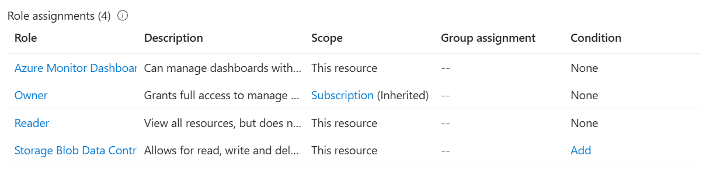

Task 2 — Network Security Group (3 marks)
Create a new NSG named according to your organisation's naming convention (include your student number) and associate it with the subnet in your virtual network from Week 4. The security team's traffic policy is partially defined below — your task is to determine the correct port numbers and protocol for the two incomplete rules, then implement all four.

Direction | Port / Protocol | Source / Dest | Action | Business Justification
Inbound | ? | ? | Allow | Remote management of VM
Inbound | ? | Any | Allow | Web application access
Inbound | Any | Any | Deny | Least-privilege default — block all other inbound
Outbound | ? | Internet | Deny | Prevent data exfiltration from VMs

The two rules marked with '?' require you to identify the standard port(s) for the described service. State your choices explicitly in your evidence document — do not just show a screenshot without explanation.

THINK | Azure NSGs have a default DenyAllInbound rule at priority 65500. Why does the explicit Deny rule in the table still need to be created? What priority number would you assign it relative to your Allow rules, and why does priority order matter?
Even though Azure NSGs include a default DenyAllInbound rule at priority 65500, an explicit Deny rule is useful to block specific traffic earlier—before any broader Allow rules might permit it.
You should assign the Deny rule a lower priority number (higher precedence) than your Allow rules (e.g., Deny at 100, Allow at 200), so it is evaluated first. Priority matters because NSG rules are processed from lowest number to highest, and the first matching rule is applied—so order determines whether traffic is allowed or blocked.

NOTE | When taking screenshots of your NSG rules, ensure both the rule name, priority, port, and action columns are fully visible. Cropped screenshots that hide any column will not be accepted for that criterion.
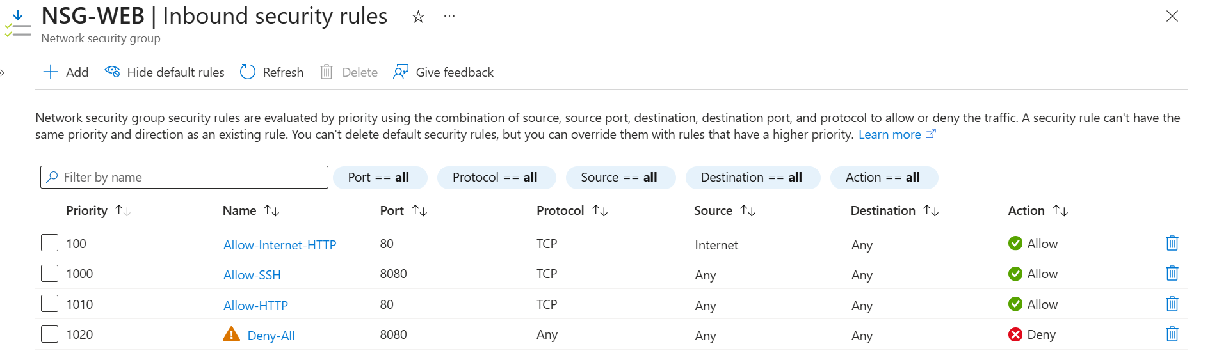
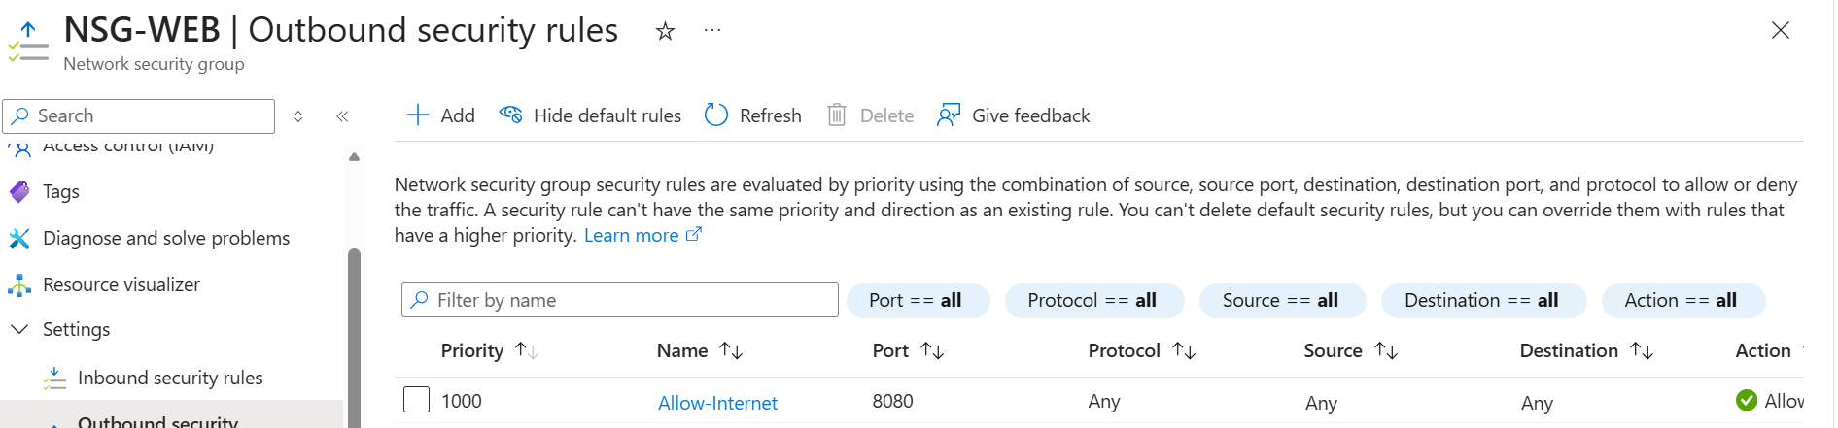
Task 3 — Storage Account & Containers (2 marks)
Provision a new Azure Storage Account within your resource group. Choose the storage account configuration that is appropriate for a general-purpose internal file repository — you will need to justify your replication and access tier choices in your evidence document.

Once the storage account is created, complete the following:
- Create at least two blob containers with different names that reflect their intended purpose (e.g. internal-docs, public-assets)
- Upload at least one sample file to each container — any file type is acceptable
- Record the storage account name, container names, and the blob endpoint URL in your evidence document

THINK | What is the difference between Locally Redundant Storage (LRS), Zone-Redundant Storage (ZRS), and Geo-Redundant Storage (GRS)? Which did you choose and why is it appropriate for a small internal repository with no disaster recovery requirement?
- LRS: Data stored in one data centre (cheapest, basic protection).
- ZRS: Data spread across multiple zones in one region (more resilient).
- GRS: Data replicated to another region (highest protection).
Chosen option:
LRS, because it is cost-effective and sufficient for a small internal repository with no disaster recovery needs.

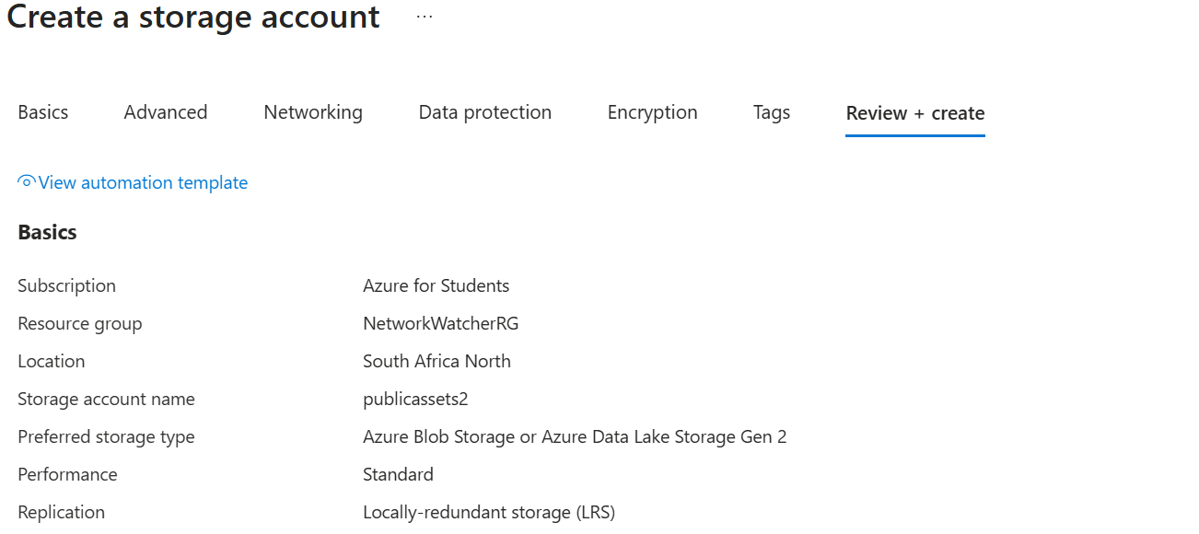
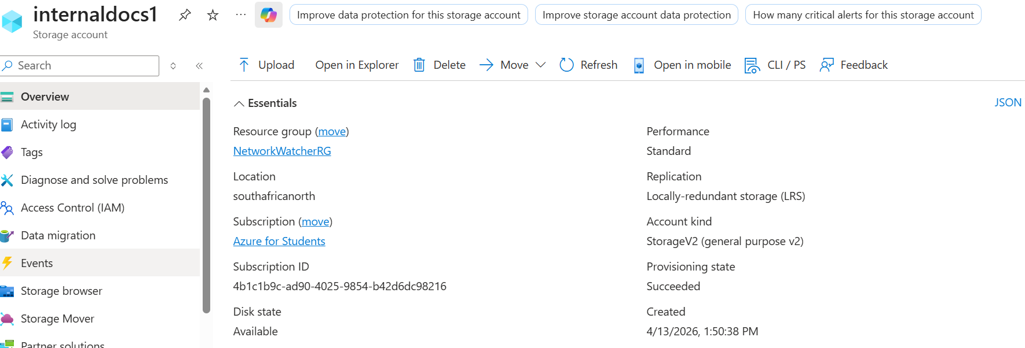
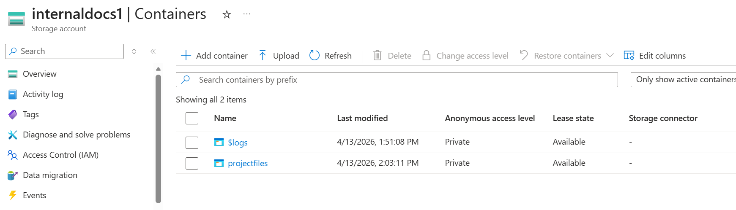
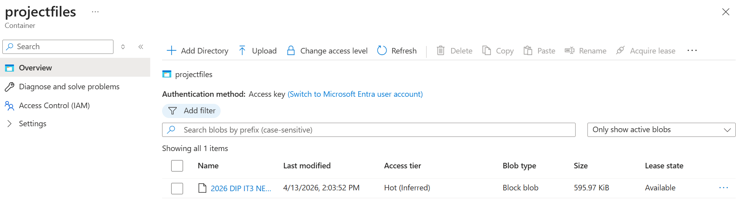
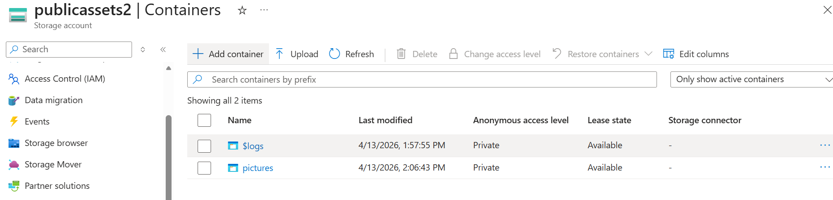
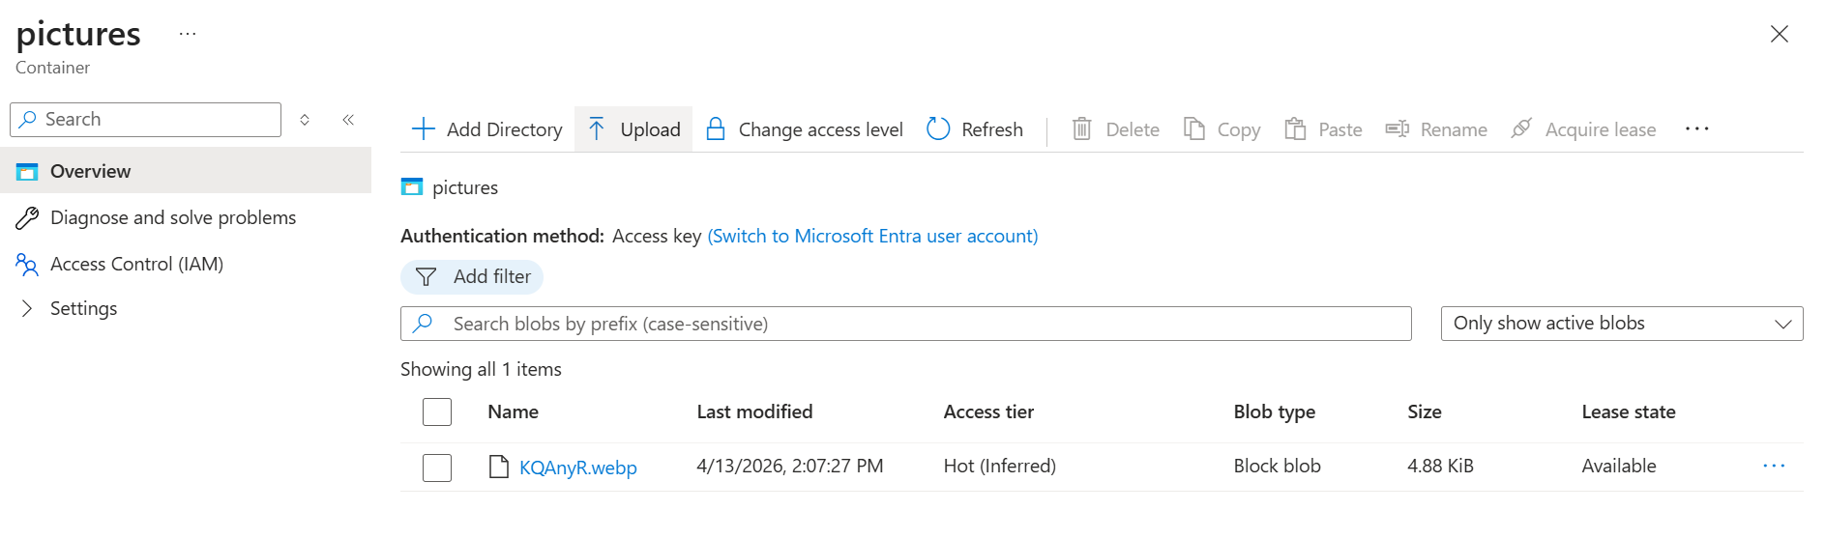
Task 4 — Storage Access Permissions (2 marks)
Configure access permissions for your storage containers so that:
- One container uses Private access (no anonymous reads) — access is controlled via the RBAC role assigned in Task 1
- One container generates a Shared Access Signature (SAS) token with a defined expiry and limited permissions (read-only is sufficient)

In your evidence document, provide the SAS token URL you generated (you may redact the last 10 characters of the signature for security) and state the expiry window you chose and why.

THINK | A SAS token grants access without requiring the caller to have an Azure AD identity. What are the security implications of sharing a SAS token via email? What would you do if a SAS token was accidentally exposed in a public GitHub repository?
Risk: SAS tokens can be used by anyone who has them, and email sharing is insecure.
If exposed: Revoke the token, rotate keys, remove it from GitHub, check for misuse, and create a safer replacement (least privilege, short expiry).

CAUTION | Do not set container access to Blob (anonymous read). Your containers must use Private access with explicit permission grants. Anonymous public access is inappropriate for an internal repository and will not receive marks for this criterion.
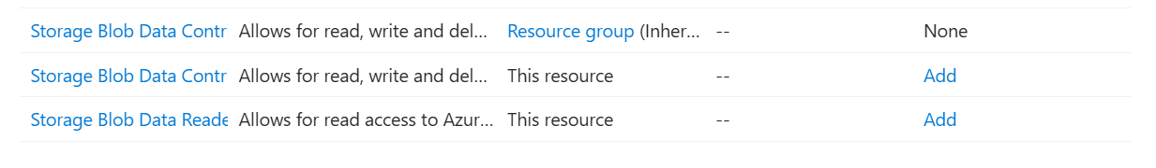
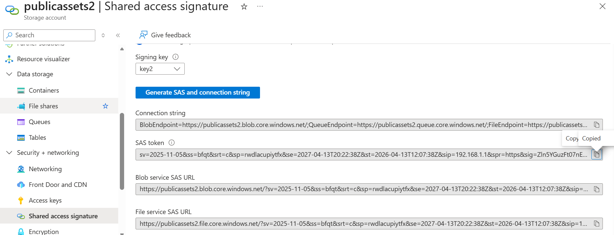
SAS Token- sv=2025-11-05&ss=bfqt&srt=c&sp=rwdlacupiytfx&se=2027-04-13T20:22:38Z&st=2026-04-13T12:07:38Z&sip=192.168.1.1&spr=https&sig=Zln5YGuzFt07nEp0f89pQwni9dWGrlMeJT43V5psKoA%3D
5. Evidence to Submit
Your submission must include all items in the checklist below. Screenshots must show the full portal blade — the URL bar and your account name (top-right corner) must be visible in every screenshot.

Evidence Item | Included ✓ | Marker Notes
RBAC — screenshot of role assignment (IAM blade showing user + role + scope)
RBAC — screenshot confirming the assigned user cannot perform an action outside their role
NSG — screenshot of inbound rules with your custom rules visible
NSG — screenshot of outbound rules with your custom rules visible
NSG — screenshot of NSG association to subnet or NIC
Storage Account — screenshot of created storage account overview blade
Storage — screenshot of container(s) created with access tier visible
Storage — screenshot confirming file upload inside a container
Storage — screenshot of blob/file access permission or SAS token configuration
GitHub — link to repository folder containing all evidence files

Compile your evidence into a single document (Word or PDF). For each screenshot, include a one-sentence caption that identifies what the screenshot is demonstrating. Upload both the evidence document and all raw screenshots to your GitHub repository.

6. Mark Allocation
Criterion | Marks | Awarded | Comment
RBAC role assigned correctly — right role, right scope, right user | 3
NSG inbound and outbound rules configured with clear justification | 3
Storage account created with container and file uploaded successfully | 2
Access permissions configured and evidenced (Blob access level or SAS) | 2
TOTAL | 10

7. Submission Instructions
- Upload your evidence document and all screenshot files to your GitHub class repository under: NET731 / Week5 /
- File naming: StudentNumber_NET731_W5_Evidence.docx (or .pdf) — raw screenshots may be in a subfolder named screenshots/
- Deadline: As communicated in class. Late submissions are subject to the standard deduction policy.
- Include the direct GitHub URL to your Week5 folder as the last item in your evidence document.

NOTE | If your Azure student subscription has expired or you are unable to access the portal due to a financial account block, contact your lecturer before the deadline. Retrospective deferment requests will not be considered.

CLEAN-UP | After your submission has been marked, delete any resources you no longer need to avoid consuming your free credit. NSGs, storage accounts, and unused VMs should be removed. Do not delete the resource group itself — it is shared across all practicals.

